|  |  |  |  |
| --- | --- | --- | --- |
|  | **Bed** | **Tool 0** | **Tool 1** |
| **Heaters**  Number  Duet plug | 0 | ~~2~~ 1  ~~e1heat~~ e0heat | ~~1~~ 2  ~~e0heat~~ e1heat |
| **Sensor** Number  (temperature) Duet plug | 0  bedtemp | ~~2~~ 1  ~~e1temp~~ e0temp | ~~1~~ 2  ~~e0temp~~ e1temp |
| **Extruder driver** Number  Duet plug |  | ~~4~~  3  ~~E1 motor~~ E0 Motor | ~~3~~ 4  ~~E0 Motor~~ E1 motor |
| **Fans** Number  (hot end) Duet plug |  | ~~3~~ 0  ~~duex.fan3~~ fan0 | ~~0~~ 2  ~~fan0~~ duex.fan3 |
| **Fans** Number  (Part) Duet plug |  | ~~4~~  1  ~~duex.fan4~~ fan2 | ~~2~~ 3  ~~fan 2~~ duex.fan4 |

**Full motor/driver table**

|  |  |  |
| --- | --- | --- |
| Use | Driver Number | Duet/duex connection |
| X motor | 0 | X |
| Y motor | 1 | Y |
|  | 2 |  |
| Tool #0 Extruder | ~~4~~  3 | ~~E1 motor~~ E0 motor |
| Tool #1 Extruder | ~~3~~ 4 | ~~E0 motor~~ E1 motor |
| Z motor (Front-left) | 6 | duex E3 |
| Z motor (Front-right) | 7 | duex E4 |
| Z motor (Rear) | 8 | duex E5 |

**Full Fan Table**

|  |  |  |
| --- | --- | --- |
| Use | Fan Number | Duet/duex connection |
| Tool 0 hot end fan | ~~3~~ 0 | ~~duex.fan3~~ fan 0 |
| Tool 0 Part cooling fan | ~~4~~ 1 | ~~duex.fan4~~ fan 1 |
| Tool 1 Hot end fan | ~~0~~ 2 | ~~Fan 0~~ duex.fan3 |
| Tool 1 Part cooling fan | ~~2~~ 2 | ~~fan 2~~ duex.fan4 |

**Full Heater Table**

|  |  |  |
| --- | --- | --- |
| Use | Heater Number | Duet/duex connection |
| Bed heater | 0 | bedheat |
| Tool 0 / Extruder 0 | 1 | e0heat |
| Tool 1 / Extruder 1 | 2 | e1heat |

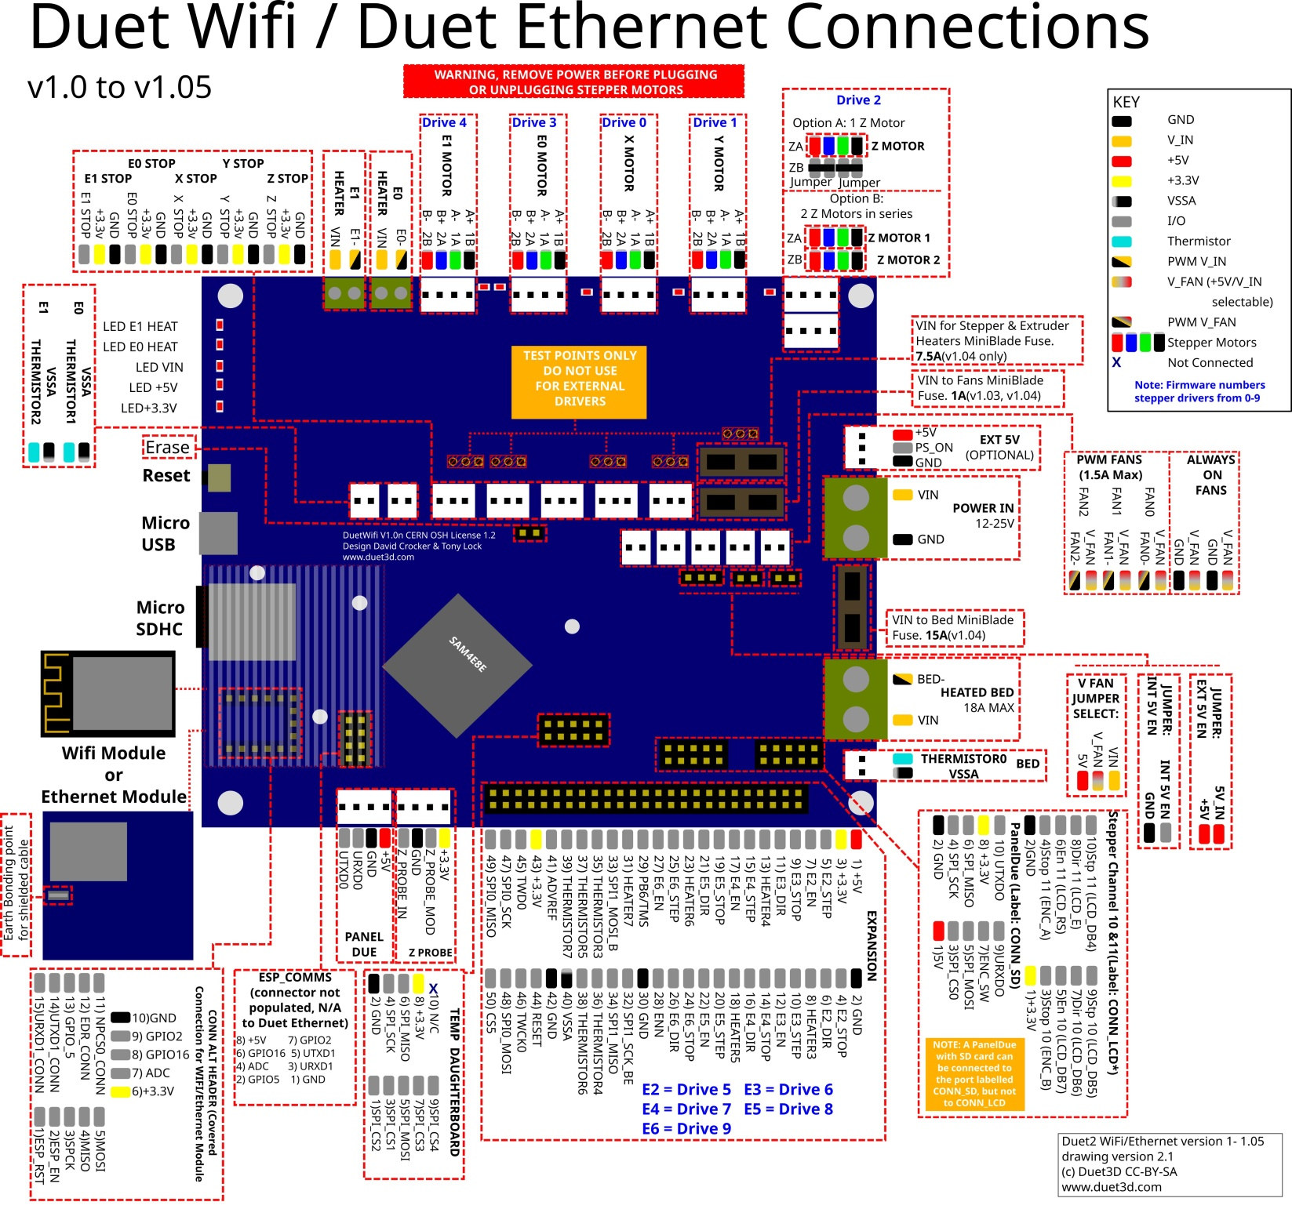

**Duet2 Pin names**

In the table below, multiple names on a line are aliases for a single pin. Some pins (primarily heater pins) have an inversion between the processor and the corresponding output, RRF3 will automatically allow for this inversion. These pins are marked with a * after the pin name in the list below. For legacy reasons some Duex pins are inverted or not, depending on the name/alias used to access them. This is indicated with a ! in front of the pin name in the sable below. e.g. exp.heater3 is the same pin as !duex.e2heat the ! indicates that the logic of the pin is inverted when referred to as "duex.e2heat"

|  |  |  |
| --- | --- | --- |
| **Pin label on Duet PCB/wiring diagram** | **RRF3 Pin name (Duet)** | **Notes / Shared with (on Duex/BoB)** |
| **Heater outputs** |  |  |
| BED HEAT | bedheat * |  |
| E0 HEAT | e0heat * |  |
| E1 HEAT | e1heat * |  |
| EXPANSION HEADER HEATER3 (pin 8) | exp.heater3, exp.8 | !duex.e2heat, !duex.pwm1 |
| EXPANSION HEADER HEATER4 (pin 13) | exp.heater4, exp.13 | !duex.e3heat, !duex.pwm2 |
| EXPANSION HEADER HEATER5 (pin 18) | exp.heater5, exp.18 | !duex.e4heat, !duex.pwm3 |
| EXPANSION HEADER HEATER6 (pin 23) | exp.heater6, exp.23 | !duex.e5heat, !duex.pwm4 |
| EXPANSION HEADER HEATER7 (pin 31) | exp.heater7, exp.31 | !duex.e6heat, !duex.pwm5 |
| Temperature inputs |  |  |
| BED TEMP | bedtemp |  |
| E0 TEMP | e0temp |  |
| E1 TEMP | e1temp |  |
| EXPANSION HEADER THERM3 (pin 35) | e2temp, exp.thermistor3, exp.35 | duex.e2temp |
| EXPANSION HEADER THERM4 (pin 36) | e3temp, exp.thermistor4, exp.36 | duex.e3temp |
| EXPANSION HEADER THERM5 (pin 37) | e4temp, exp.thermistor5, exp.37 | duex.e4temp |
| EXPANSION HEADER THERM6 (pin 38) | e5temp, exp.thermistor6, exp.38 | duex.e5temp |
| EXPANSION HEADER THERM7 (pin 39) | e6temp, exp.thermistor7, exp.39 | duex.e6temp |
| Fan outputs |  |  |
| FAN0 | fan0 |  |
| FAN1 | fan1 |  |
| FAN2 | fan2 |  |
| Endstop inputs |  |  |
| X_STOP | xstop |  |
| Y_STOP | ystop |  |
| Z_STOP | zstop |  |
| E0_STOP | e0stop |  |
| E1_STOP | e1stop |  |
| EXPANSION HEADER E2_STOP (pin 4) | exp.e2stop, exp.4 |  |
| EXPANSION HEADER E3_STOP (pin 9) | exp.e3stop, exp.9 | duex.cs6 |
| EXPANSION HEADER E4_STOP (pin 14) | exp.e4stop, exp.14 | duex.cs7 |
| EXPANSION HEADER E5_STOP (pin 19) | exp.e5stop, exp.19 | duex.cs8 |
| EXPANSION HEADER E6_STOP (pin 24) | exp.e6stop, exp.24 |  |
| Miscellaneous |  |  |
| Probe IN | zprobe.in |  |
| Probe MOD | zprobe.mod |  |
| CONN_LCD ENC_B | connlcd.encb, connlcd.3 | (also used for endstop 11) |
| CONN_LCD ENC_A | connlcd.enca, connlcd.4 | (also used for endstop 10) |
| CONN_SD ENC_SW | connsd.encsw, connsd.7 |  |
| EXPANSION HEADER PB6/TMS (pin 29) | exp.pb6, exp.29 | duex.pb6 |
| SPI CS |  |  |
| SPIO CS1 (Temp DB, pin 3) | spi.cs1 |  |
| SPIO CS2 (Temp DB, pin 1) | spi.cs2 |  |
| SPIO CS3 (Temp DB, pin 7) | spi.cs3 |  |
| SPIO CS4 (Temp DB, pin 9) | spi.cs4 |  |
| EXPANSION HEADER CS5 (pin 50) | spi.cs5, exp.50 | duex.cs5 |
| EXPANSION HEADER E3_STOP (pin 9) | spi.cs6, exp.e3stop, exp.9 | duex.cs6 |
| EXPANSION HEADER E4_STOP (pin 14) | spi.cs7, exp.e4stop, exp.14 | duex.cs7 |
| EXPANSION HEADER E5_STOP (pin 19) | spi.cs8, exp.e5stop, exp.19 | duex.cs8 |

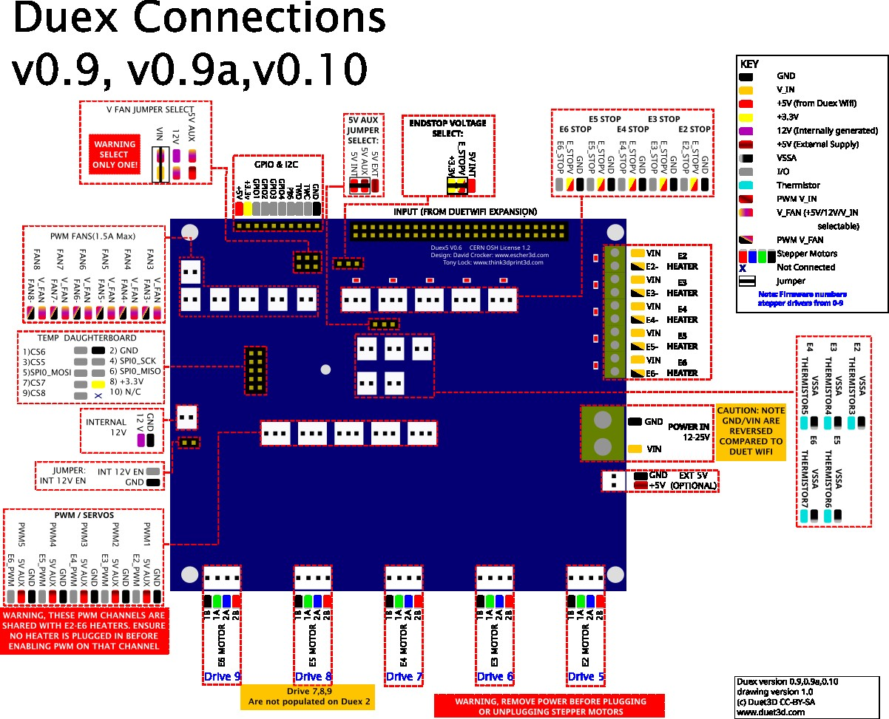

|  |  |  |
| --- | --- | --- |
| **Label/pin on DueX PCB/wiring diagram** | **RRF3 Pin name (DueX)** | **Shared with (on Duet)** |
| Heater outputs |  |  |
| E2 HEATER, E2-, PWM_1, E2_PWM | duex.e2heat, duex.pwm1 | !exp.heater3, !exp.8 |
| E3 HEATER, E3-, PWM_2, E3_PWM | duex.e3heat, duex.pwm2 | !exp.heater4, !exp.13 |
| E4 HEATER, E4-, PWM_3, E4_PWM | duex.e4heat, duex.pwm3 | !exp.heater5, !exp.18 |
| E5 HEATER, E5-, PWM_4, E5_PWM | duex.e5heat, duex.pwm4 | !exp.heater6, !exp.23 |
| E6 HEATER, E6-, PWM_5, E6_PWM | duex.e6heat, duex.pwm5 | !exp.heater7, !exp.31 |
| Temperature inputs |  |  |
| E2_THERMSTOR3 | duex.e2temp | e2temp, exp.thermistor3, exp.35 |
| E3_THERMSTOR4 | duex.e3temp | e3temp, exp.thermistor4, exp.36 |
| E4_THERMSTOR5 | duex.e4temp | e4temp, exp.thermistor5, exp.37 |
| E5_THERMSTOR6 | duex.e5temp | e5temp, exp.thermistor6, exp.38 |
| E6_THERMSTOR7 | duex.e6temp | e6temp, exp.thermistor7, exp.39 |
| Fan outputs |  |  |
| FAN3 FAN3- | duex.fan3 | Note: the duex.fan pins cannot be used to control a laser. |
| FAN4 FAN4- | duex.fan4 |  |
| FAN5 FAN5- | duex.fan5 |  |
| FAN6 FAN6- | duex.fan6 |  |
| FAN7 FAN7- | duex.fan7 |  |
| FAN8 FAN8- | duex.fan8 |  |
| Endstop inputs |  |  |
| E2_STOP | duex.e2stop | The duex.estop pins are routed through the I2C expander on the DueX. The exp.e[x]stop pins on the Duet expansion header become the CS pins on the DueX temp daughterboard connector. |
| E3_STOP | duex.e3stop |  |
| E4_STOP | duex.e4stop |  |
| E5_STOP | duex.e5stop |  |
| E6_STOP | duex.e6stop |  |
| Miscellaneous |  |  |
| GPIO & I2C PB6 | duex.pb6 | exp.pb6, exp.29 |
| GPIO & I2C GPIO1 | duex.gp1 | Note: the duex.gp1-4 pins cannot be used to control a laser. |
| GPIO & I2C GPIO2 | duex.gp2 | Note: the duex.gp1-4 pins have a permanent 10K pullup to 5V |
| GPIO & I2C GPIO3 | duex.gp3 |  |
| GPIO & I2C GPIO4 | duex.gp4 |  |
| SPI CS |  |  |
| TEMP DB CS5 | duex.cs5 | spi.cs5, exp.50 |
| TEMP DB CS6 | duex.cs6 | spi.cs6, exp.e3stop, exp.9 |
| TEMP DB CS7 | duex.cs7 | spi.cs7, exp.e4stop, exp.14 |
| TEMP DB CS8 | duex.cs8 | spi.cs8, exp.e5stop, exp.19 |